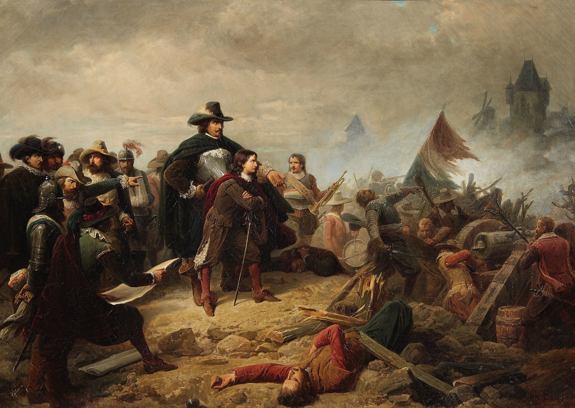A Statesman’s Guide to War

*“It is forbidden to kill; therefore all murderers are punished unless they kill in large numbers and to the sound of trumpets.*”   
― Voltaire

The art of war is not so clean as the other arts. It is messy, brutal, sorrowful and only serves to accomplish the goals of the statesman. However, as a statesman, you may thus have a rosier view of war. This guide will show you, then, how to conduct war within Conquest and Imperialism.

The primary action in war is the positioning of armies in **provinces** on a map. Provinces are controlled by **whichever side has total military presence there**, or has legal authority if there are no armies present. Battles occur when a province is **contested,** meaning where there are multiple sides with a military presence there. In such a case, the sides are referred to as “**Defender**” and “**Attacker**”. The Defender is the side that has entered the province first, and the Attacker is the side that has entered the province last. In the case where both arrive at the same time, the Defender is the side who legally owns the territory. Importantly, the Attacker gets the first turn in a battle.

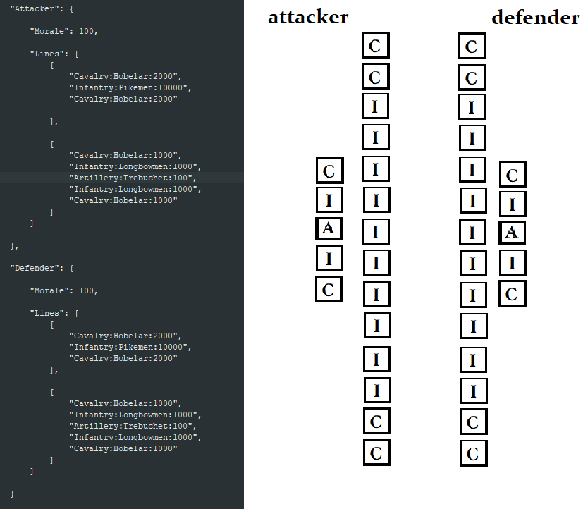 An army may choose to stay for multiple turns in a province, setting up for a defense. Defensive preparations take two forms – **terrain** positioning and **man-made defenses**. The former is very simple to describe: Each terrain has a modifier to defensive advantage from +0 to +3 as well as possibly a **combat width**.This is a limit to how large each line in a battle can be. Man-made defenses, on the other hand, come in a variety of flavors. Some, like Strongholds and Castles, can be constructed as projects by a nation and are called **permanent defenses**. Others, such as spikes and earthen ramparts, can be constructed on the turn of a battle. These are called **temporary defenses.** One can be built for every turn spent in a province by an army, but all are gone when the army leaves.

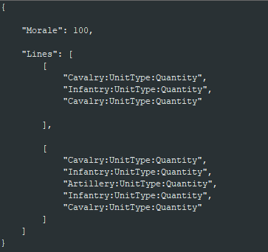 When two armies meet in a province, they will begin battling. Each side will be given information about the troops on the other side upon both entering the province. will form lines composed of their given troops and send these in as **orders** to the relevant Game Master. The orders will look like how they are written to the right. An order is written in **.json** format, which is a kind of text file used for organizing data easily. More detailed instructions will be written down in the “Orders format” section. Remember to write your orders in the exact format shown, with all unit names written exactly as they are in the units sheet! **The GMs should not have to go through and change your orders!**

**Morale** is simply a number from 0-100, representing how close your army is to breaking. **Lines** are what are important. An army can have any number of lines, but depending on the terrain, the lines themselves may have a size limit. The lines written from **top to bottom** will be arranged as from **front to back.** This means that the top line will be the front-most line in the battle. Within a line, each unit from **top to bottom** will be arranged from **top to bottom** as well, as shown in the image above (side note: The image above **is not exactly how you should format your armies**. It is merely how the program organizes them). If an Infantry or Cavalry unit has more than 1000 personnel, it will be **automatically split into groups of 1000**. Each I and C square above represents either 1000 infantry or 1000 cavalry. Artillery behaves the same except it is split into groups of 100.

Each Unit, with statistics defined by the unit sheet, has **Fire, Cover, Charge, Shock** and **Range** modifiers. Fire is ranged attacking power, Cover is ranged defense, Charge is melee attacking power, Shock is melee defense and Range is the amount of lines away a unit can attack. Additionally, Artillery has **Force** and **Firing Speed.** Force is the amount of damage a piece of artillery can do and Firing Speed is how often it can fire. Artillery by default has a Fire, Cover, Charge and Shock of 0 instead of using them. During a battle, units have their own individual starting morale related to the overall morale of the army at that point. As the battle progresses, each division will be able to attack another, causing both casualties and loss of morale. Once their morale has gone below 25, they will **rout** (be destroyed) and their associated line will come closer together. When one line is bigger than the other, the bigger line will be able to **encircle** the smaller one by attacking the flanks with a small bonus (larger with cavalry). Once a line has been fully routed, then the line behind it will become the front line. Once the average morale of an army is under 25, or 25 battle phases have been run, the battle ends either decisively or inconclusively, respectively.

Sometimes a battle will be a **siege.** In such a case, battle is not mandatory, but the attacking army may choose to **assault** the defending position or the defender may choose to **attempt to break the siege.** If neither army chooses to mount an attack, then the defending army will slowly deteriorate until its morale is too low, it dies out or the siege is relieved. Sieges will occur when the defender is specifically ordered to garrison a city or fort.

Orders Format

{

"Morale": 100,

“Defenses”: [

“Spikes”,

“Palisades”,

“Village”

],

"Lines": [

[

“UnitType:Unit:Quantity”,

“UnitType:Unit:Quantity”,

“UnitType:Unit:Quantity”

],

[

“UnitType:Unit:Quantity”,

“UnitType:Unit:Quantity”,

“UnitType:Unit:Quantity”,

“UnitType:Unit:Quantity”

]

]

},

Notes:

* *Green: Morale, Red: Defenses, Blue: Basic Lines, Yellow: Units format*
* *Defenses are not always applicable: Attackers have none, and defenders may have none too*
* *Commas are important: Put them at the end of everything except the last items!*
* *Quotations are important too: Put all words in quotations as shown above!*
* *The formatting style is called “json”, for reference*
* *There is no limit to the number of lines you may have, just a limit to their size. Too-large lines will automatically be divided.*

Defensive Modifiers

TERRAIN:

* Mountains: +3, Combat Width = 10
* Glacial: +3, Combat Width = 15
* Amphibious Assault: +3
* Jungle: +3, Combat Width = 10
* Marsh: +3, Combat Width = 20
* Hills: +2, Combat Width = 20
* Highlands: +2, Combat Width = 20
* Forest/Woods: +2, Combat Width = 25
* River Crossing: +1
* Desert: +1
* Drylands: +1
* Coastal Desert: +1
* Steppe: +0
* Savannah: +0
* Coastline: +0
* Grassland: +0
* Farmland: +0

PLAYER-DEFINED:

* City: +3
* Stronghold: +3
* Advanced Trench-works: +3
* Castle: +2
* Town: +2
* Basic Trenches: +2
* Village: +1
* (Impermanent) Earthen Ramparts: +1
* (Impermanent) Palisades: +1
* (Impermanent) Spikes: +1